**Individual Assignment questions (Social Network)**

The questions below are related to the group assignment and lectures but are not suitable for group work. Please answer these questions individually in writing, and submit the result on Blackboard by the end of April 11th.

# (Question 1, 8 points)

Read the research paper “Students under lockdown: Comparisons of students’ social networks and mental health before and during the COVID-19 crisis in Switzerland”, available from: https://journals.plos.org/plosone/article?id=10.1371/journal.pone.0236337

Answer following quetions within 600 words:

1) The five types of social relations the authors are taking into account to build the social network and how these networks might differ in function, intimacy and stability

In this article, we take into account multiple dimensions of social relations. We assess change in five self-reported social networks within the student community: pleasant interactions, friendships, emotional support, informational support, and co-studying. We chose those networks as they differ in function, intimacy, and stability. We assume that stronger relationships will be characterized by an overlap in multiple dimensions [15]. We hypothesize that students at the time of the COVID-19 crisis *nominate fewer fellow students* than before in multiple dimensions of their social networks (*H1a*). We expect that social networks between students are less connected, and thus will show a *higher rate of students being socially isolated* (*H1b*). We hypothesize that *stronger ties are more likely to survive* at the time of crisis, thus when they are characterized by a previous overlap in multiple relational dimensions (*H2*).

In this study, we investigate the change in social networks (social interactions, social support,

study collaboration, friendship) and mental health (depression, anxiety, loneliness, stress) of

students in two undergraduate programs at a Swiss university at the time of the COVID-19 crisis.

2) What types of metrics do the authors use to measure the social network during and prior lockdown? And how do these metrics change?

Panel a compares the average number of nominations (outdegree) across five self-reported networks (pleasant interaction, friendship, costudying, informational support, emotional support) mental health indicators (depression, anxiety, stress, loneliness)

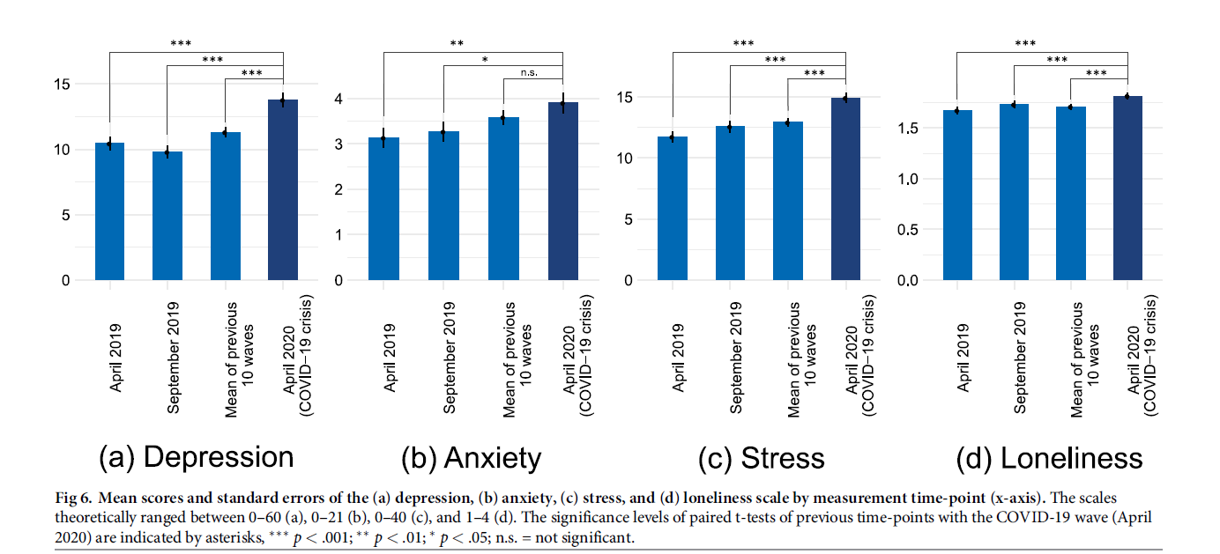

For each type of network captured by these items, we construct two key measures to test Hypotheses 1a and 1b: the *outdegree* of each respondent, i.e. the number of ties that each participant reports in each network, and the proportion of *out-isolates*, i.e. the fraction of all participants who reported no ties in a network. To test Hypothesis 2, we use the overlap of multiple ties within pairs of individuals collected in September 2019 as a signal of tie strength.

3) How do the authors analyze the face-to-face interaction network and digitial interaction network during COVID-19 crisis? What are their conclusions?

Fig 3 visualizes the reported interaction networks between students at the time of the COVID-19 crisis. As a consequence of the university lockdown and Swiss policies on social distancing, only few face-to-face interactions were reported by students (Panel a). Yet, students had pleasant interactions in general (*MInteraction* = 5.62 ties, see Fig 2, Panel a). They reported to interact through text messaging, voice and video calls, and through social media (*MMessaging* = 2.81;*MCalls* = 2.94, *MSocial Media* = 0.41 ties). The union of these networks is indicated by blue ties (any interaction). Messaging, calls and social media ties are shown in red, green and yellow, respectively. The relative network density and overlap between them is shown in a Venn diagram in Fig 3. The interaction networks were overlapping, but not identical. 85% of the call ties and 90% of the messaging ties were reported as pleasant interactions. 64% of the messaging ties were also reported as call ties, and 70% of the call ties as messaging ties. Seventy-five percent of the physical interactions were overlapping with any of the digital communication networks. Additional Venn diagrams showing these overlaps can be found in the S1 Appendix. It appears that while physical interactions were rarely possible, students conducted their social interactions largely in the digital realm. Overall, however, the number of reported interactions dropped, as reported above. Additional network visualizations that illustrate tie change and social isolation in the co-study and social support networks are provided in the S1 Appendix.

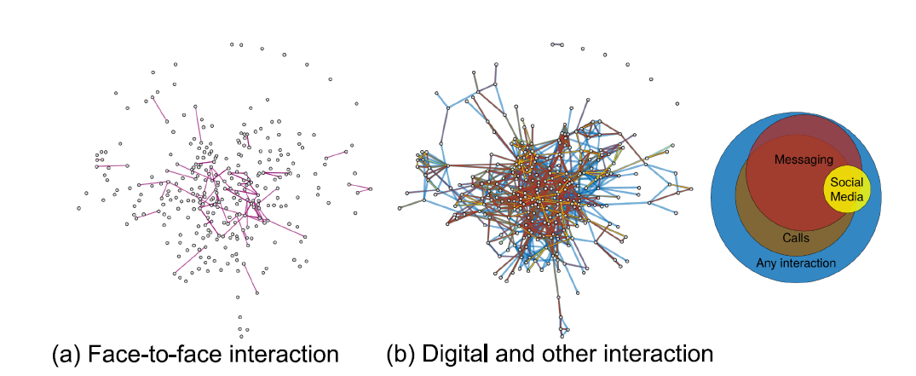

**Fig 3. Social interaction networks between students during the COVID-19 crisis (April 2020).** (**a**) Few face-to-face interactions

were reported (pink ties). (**b**) Interaction networks through digital communication technologies were dense (social media: yellow

ties, messaging apps: red, video and voice calls: brown, other pleasant interaction: blue). The Venn diagram indicates relative density

and overlap between networks. Data from the current-year cohort, Major II (*N* = 294. This includes, in addition to all respondents to

the April 2020 survey, all students enrolled in Major II who were nominated as connections by those who filled out the survey).

4) What do the author mean by ‘survivied ties’? And which type of social ties survive better during COVID time?

Survived ties or survival ties, evaluate the survival rate of each number of overlapping dimensions (i.e., 0–4) relative to the baseline survival rate of the network. The baseline survival rate represents the proportion of, e.g., interaction ties, that were present in the September 2019 wave and the April 2019 wave *irrespective* of how many overlapping dimensions there were in September 2019. The survival rate of each category of overlapping ties is then computed solely on the subsample of which a given number of overlapping ties existed in September 2019. This way we can assess if having overlapping network dimensions in September 2019 contribute to the survival of ties until April 2020.

It reports the empirical probability of interaction and studying ties to survive, thus to be reported in April 2020 after being reported in September 2019. Panel a shows that while in general 66.6% of the interaction ties survived (dashed line), the survival rate was only 45.4% for ties that did not coincide with any other of the four network relations (friendship, studying, informational, or emotional support). When interaction was reported with two to four of these networks in September 2019, the tie survival rate was between 84.9 and 87.2%. The pattern is similar in Panel b, which compares survival rates of co-studying ties. Ties that did not coincide with interaction, friendship, informational, or emotional support only had a 5.9% survival rate, while ties that overlapped with all four dimensions survived in 57.1% of the cases. The average survival rate was 44.7%.

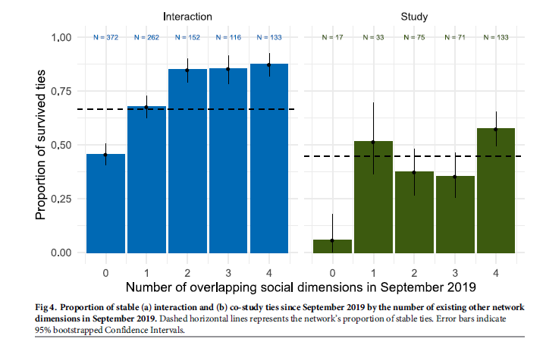

5) What will be the policy implications that you will draw based upon their results?

The results of the COVID-19 items support the expectation that some aspects of students mental health decrease (e.g., social isolation, general worries) while other stressors (e.g., Fear of Missing Out, student competition) are reduced during the COVID-19 crisis, as proposed in Hypothesis 3. The overall levels of mental health in comparison with the September 2019 wave show a clear decreasing trend. These findings complement earlier empirical research discussing the importance of social networks on well-being and mental health, and gendered differences in the size of social support networks, e.g.. They are further in line with studies showing those individuals who worry more, who are more socially isolated and receive less social support are more likely to develop mental health problems. Those individuals are also more at risk for serious health conditions. Students’ social networks and mental health trajectories cannot be understood independently of each other.

It is therefore important to study how the COVID-19 crisis and related measures affect the social networks and mental health of students. It appears that the university lockdown and social distancing measures negatively affect the social integration of some individuals, partly leaving them isolated, while in fact more social support might be needed to cope with the additional stress factors.

So, in conclusion measures of social isolation to contain covid spread is necessary, but universities and government should take in account possible increase in mental problems. I would suggest try to mix at maximum as possible social interaction, or by restricted number of students, or classes and labs with “open cameras”, group works to try to increase or “force” social interaction.

# QUESTION 2 – 8 points

Rumors are the basis for viral marketing and, therefore, rumors diffusion is a topic widely studied. Zanette 2001 developed a rumor spreading model based on the epidemiological SIR model. Read the paper of Zanetee 2001 and answer 1) how did they reframe the popluations in epidemiology (i.e., S, I, R) into a rumor spreading process? Mazzoli et al. (2018) twisted the model into an agent-based model (ABM) to simulate rumor spreading. Read the paper of Mazzoli et al. (2018) and summarize 2) how did Mazzoli et al. set up an ABM to simulate the real-like diffusion of information and misinformation (e.g., what are the agents in their ABM, assumptions on the micro behaviours of agents, and key paramters)? And 3) how well did Mazzoli’s model reproduce the diffusion of information during the announcement of the discovery of the Higgs Boson on Twitter? (Provide your answer within 500 words, Question 2, 8 points)

Paper:

Dami´an H. Zanette, 2001. Critical behavior of propagation on small-world networks, avaliable from <https://arxiv.org/abs/cond-mat/0105596>.

Mattia Mazzoli, Tullio Re, Roberto Bertilone, et al, 2018. Agent Based Rumor Spreading in a scale-free network, available from: <https://arxiv.org/abs/1805.05999>.

Describe the principles of independent cascade, threshold models, and epidemiology models such as SIS and SEIR models. Can you intefer the assumptions that each of them make on the dismission of signal within the network? Under each model, provide one real-world example that might fit their assumptions and explian why. (Question 3, 8 points)

In Ex 3 of group assignment, the threshold model assumes a deterministic threshold, e.g., one will adopt only if the fraction of one’s neighbour exceed a certain amount (threshold *qi*):

F(xi)=1 | xi>=qi

F(xi)=0 | xi<qi

where F(xi) is the probability function of node i to adopt, subject to the xi, which is the fraction of adopters in node *i*’s neighbours; and qi is the threshold of node *i*.

Such a clear-cut adoption function, however, might violate the complexity in human being’s decision making process. Empricial adoption rates with k and k-1 neighbouring adopters ofter have similar magnitudes. Rather than positing determinism, analyses of discrete choice problems typically hypothesize that individuals are random utility maximizers leading to postive choice probabilities. Embracing such complexties in human decision-making, efforts are made to fine tune the probability function of threshold model.

One way is to allow a small proabality of below-threshold aodption.

F(xi)=1 | xi>=q1,i

F(xi)=pi | q2,i <xi<q1,i

F(xi)=0 | xi<q2,i

where F(xi) is the probability function of node i to adopt, subject to the xi, which is the fraction of adopters in node i’s neighbours; q1,i is slightly smaller to the original qi, and exceed which will lead to an adoption for sure; q2,i is somewhere between q1,i and 0, which will lead to a small chance of adoption (pi) if exceeds.

The other way is to change the deterministic adoption function to an ‘S-Shape’ logit function.

$$F(xi)=\frac{1}{1+exp (-\frac{xi+qi}{b})}$$

Where F(xi) is the probability function of node i to adopt, subject to the xi, which is the fraction of adopters in node *i*’s neighbours; and qi is the threshold of node *i*; b is a new parameter that is introduced to control the shape of the probability funciton.

For a given seed size, change the deterministic probability function to the above two more realistic assumptions (i.e., one allows below-threshold adoption, the other with S-shape logit function) and play around the parameters such as pi, q1,i, q2,i and b. Check how does such more realistic assumptions affect 1) final diffusion size, 2) the shape of diffusion curve, and 3) the target nodes of seeding. (Notes: to make results comparable, you should make sure the expected values of thresholds are the same cross different assumptions; you can work on the network and the threshold model for the vegetarian reciept in the group assignment or use your own data and threshold distribution; you should test the result for different seed sizes as it might change your conclusion) (Question 4, 14 points)

**BONUS QUESTION:**

After the introductions of more realistic assumptions of threshold, do we need more weak ties to accelerate diffusion, or the opposite (i.e., we need more strong ties to accelerate diffusion)? Can you test your conjecture by rewiring the network strucutre (e.g., adding long ties or triadic closure) and monitoring the change of diffusion scale and speed? (Question 5, 5 points).